**Experiment No. 3.3**

**Student Name: Rishav Kumar UID: 22MCC20039**

**Branch: MCA - CCD Section/Group: MCD-1/ Grp A**

**Semester: III Date of Performance: 9th Oct 23**

**Subject Name: DevOps Process Automation Lab Subject Code: 22CAP-745**

1. **Aim/Overview of the practical:**

Pulling Docker Images from Docker Hub

**Code for practical:**

* Login to Docker server using ssh key

***ssh root@172.105.36.128***

* Use command to login to docker

***docker login***

* To pull image from private repository, use

***docker pull repo_name***

***docker pull rishav518/Tailblocks***

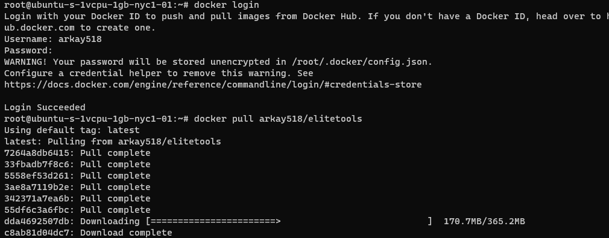

* Image will be pulled to server in moments.
* To pull any public reposiroty, use following commands

***docker pull nginx*** [for nginx server]

***docker pull python:3.1*** [for python with version 3.1]

***docker pull alpine*** [for alpine server]

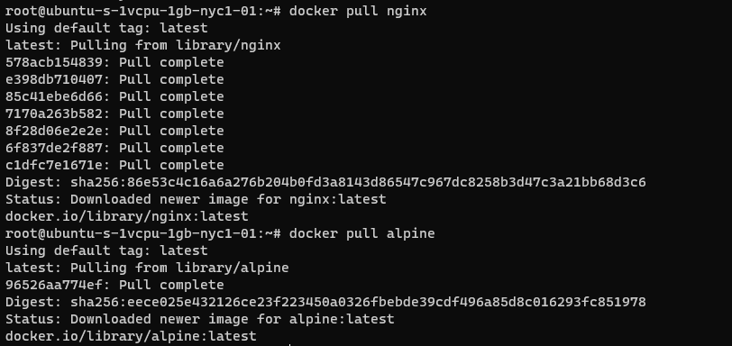

* Verify pulled images in docker images using

***docker images***

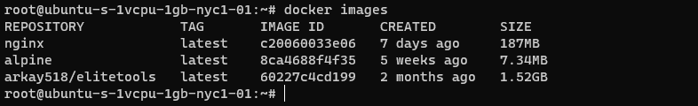

**************************************** **THE END** ***********************************************